Scripting Task
Task Description:
Create a shell script to print the HTTP error code of guvi.in & print, the success/failure message based on the error code response

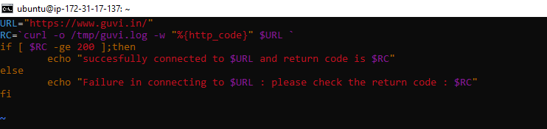

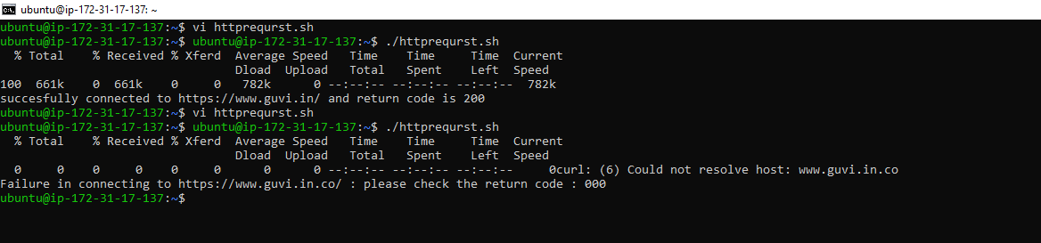
Given a file, replace all occurrence of the word "give" with "learning" from 5th line till the end in only those lines that contain the word "welcome"
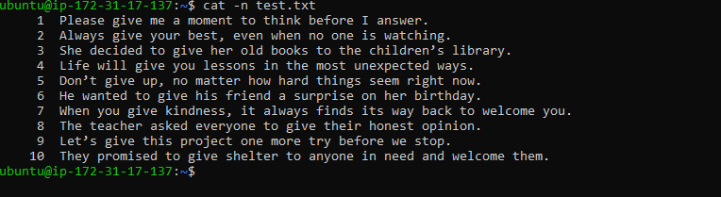
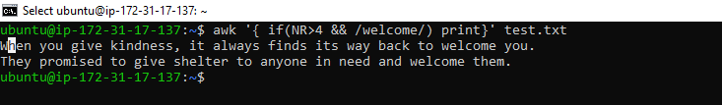
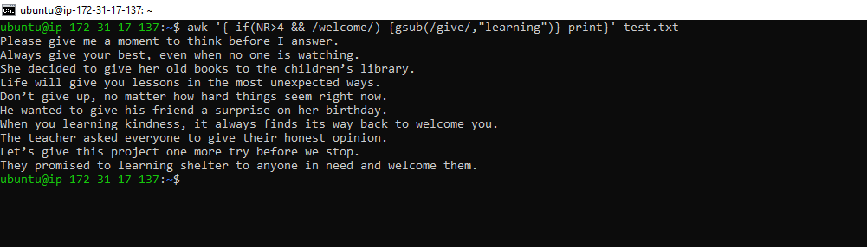

- Filter the file with line number after 4
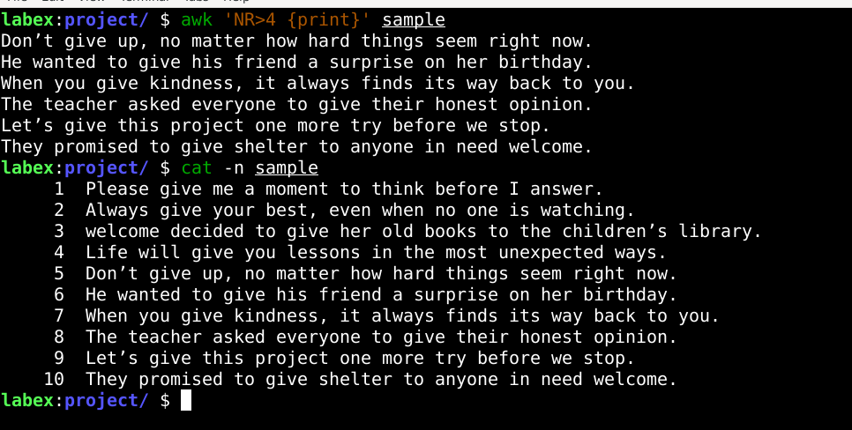
Step2: find the lines having welcome
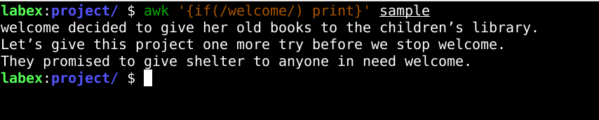
STEP3: replacing give with leaning
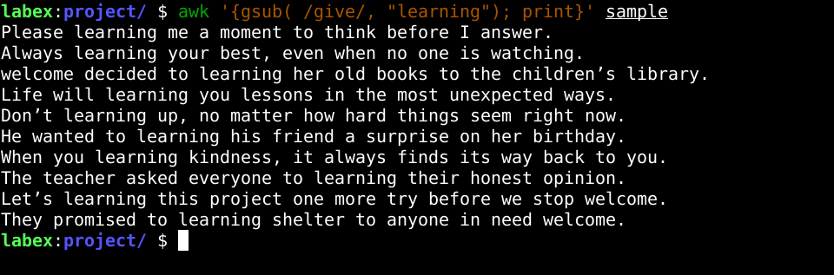
Given a file, replace all occurrence of the word "give" with "learning" from 5th line till the end in only those lines that contain the word "welcome"

